1. Mismatch Menu icon and name display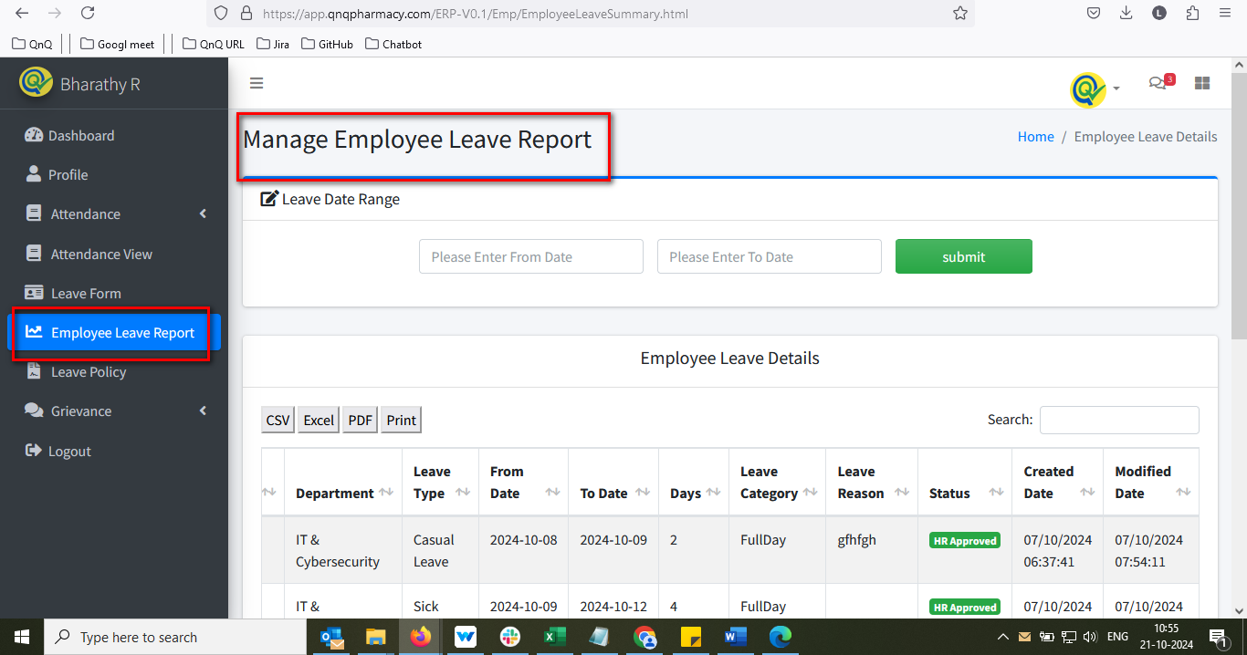//
2. Leave summary not display based on the date filter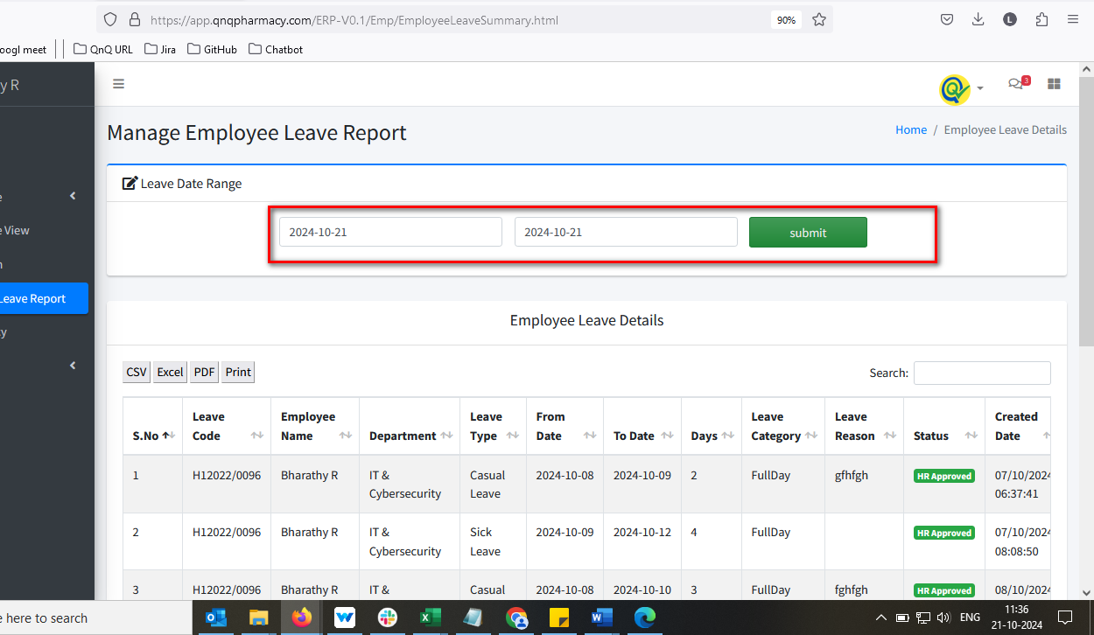//
3. Date required error message not display while click submit button 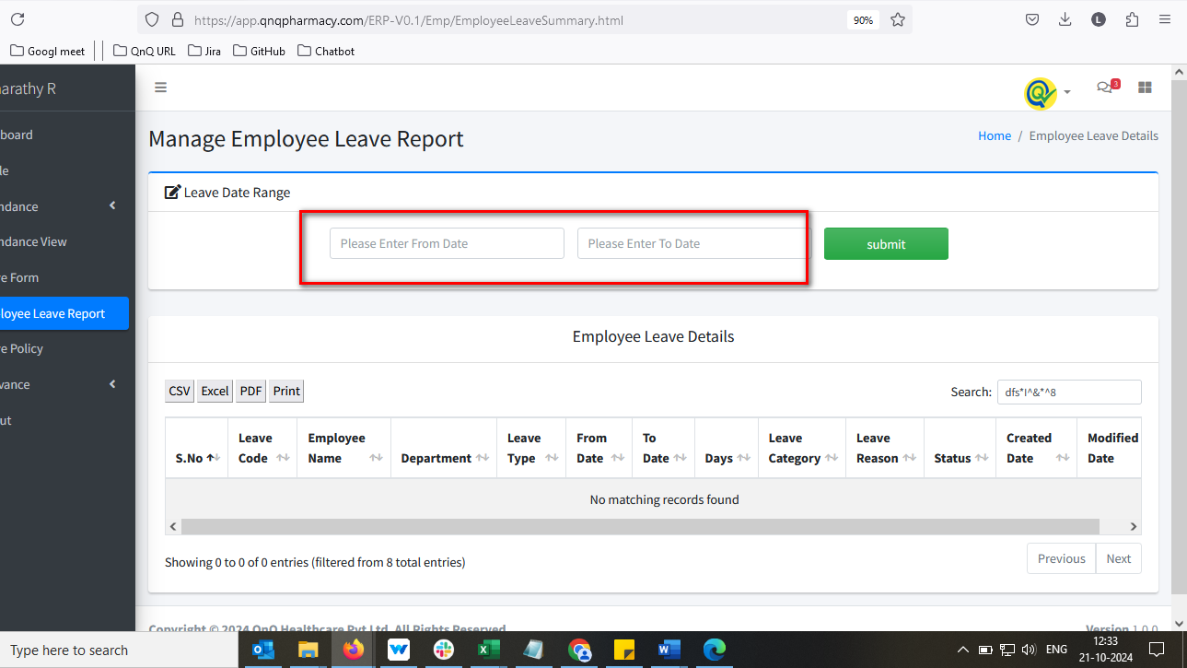 //
4. Error message not display while invalid date range 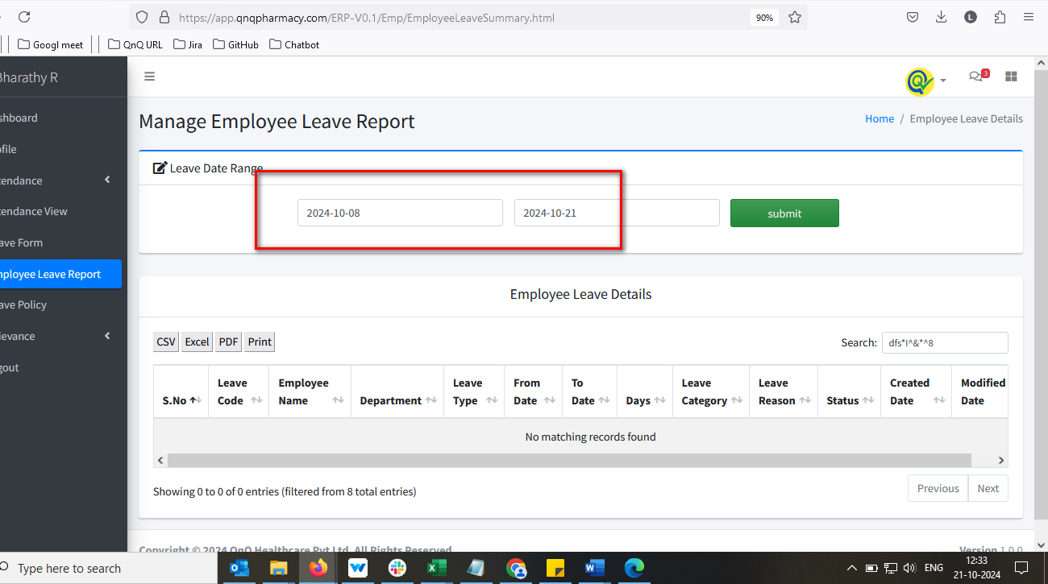 //
5. Mismatch column header name display 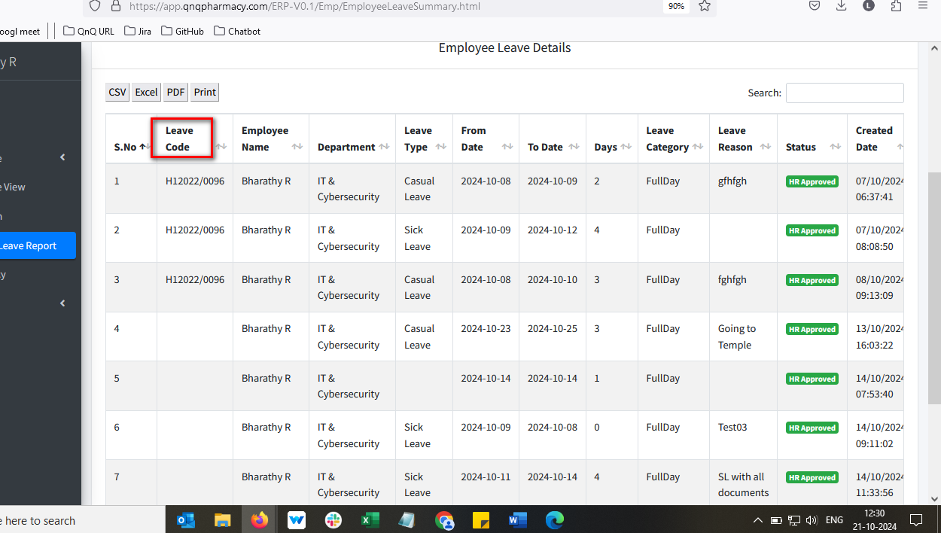 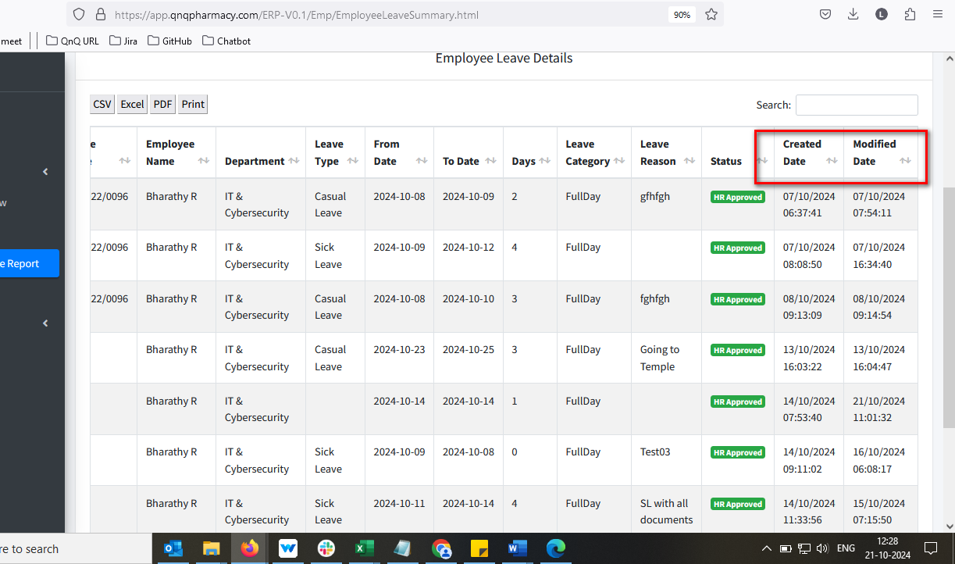 //
6. The time value is shown, but the column header isn’t labelled accordingly 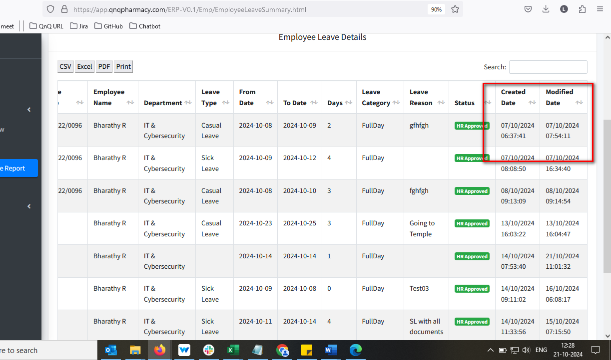 //
7. Inner Text value not display in Search box 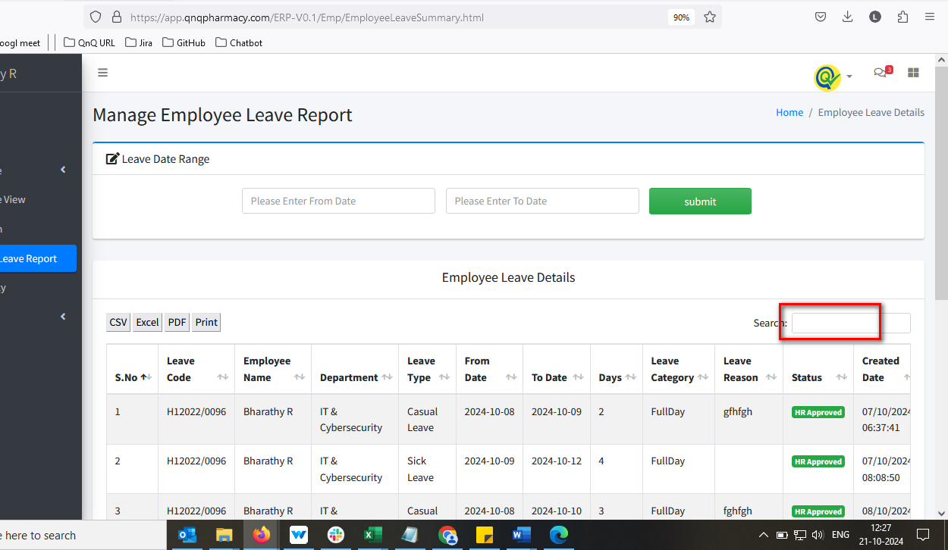 //
8. Showing count dropdown not display in list grid 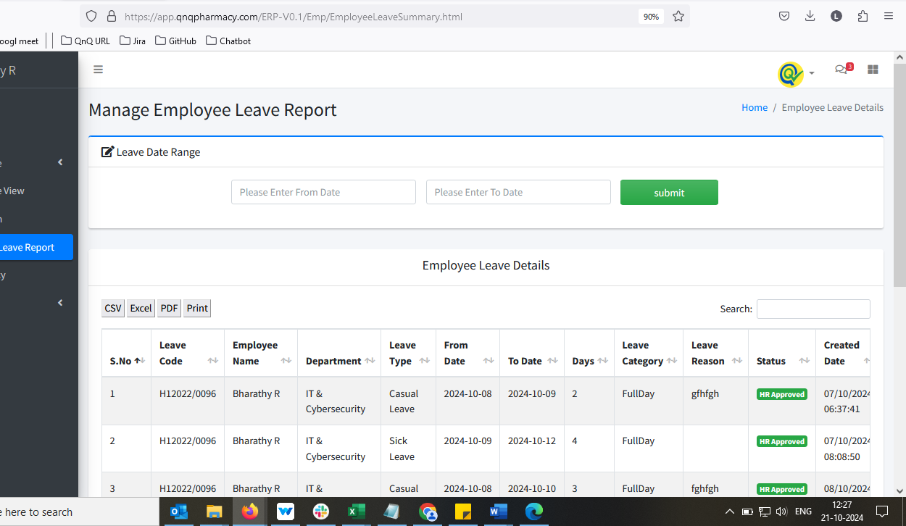 //
9. Employee Code display as Empty in Leave form pop up 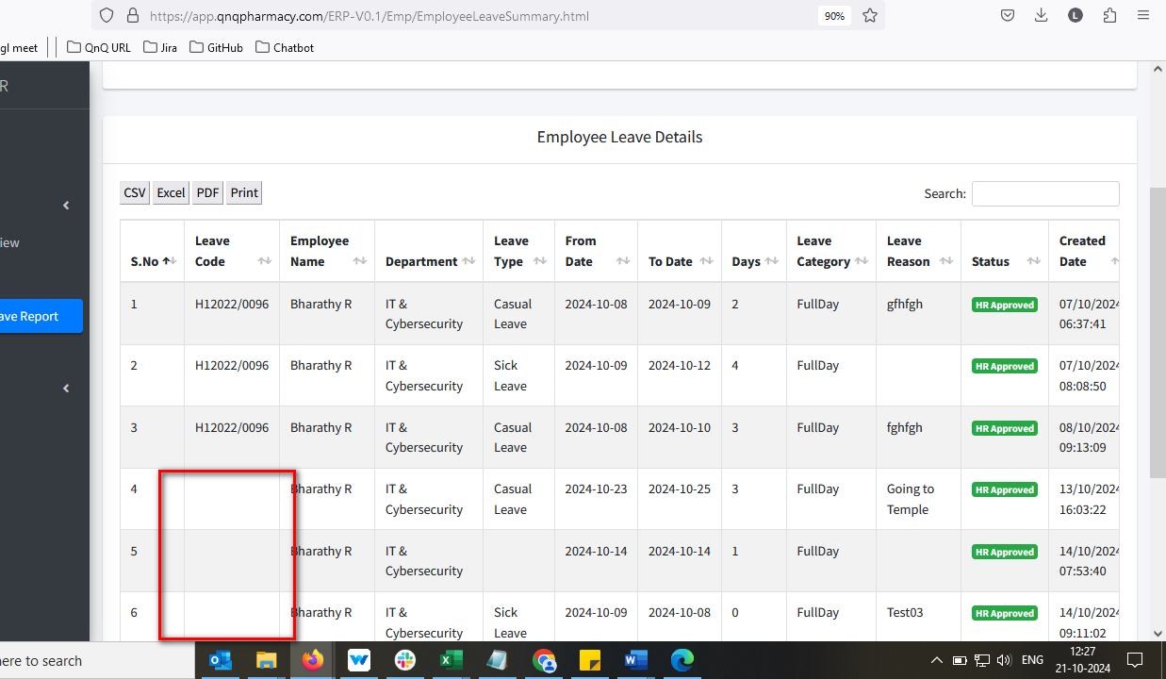 //
10. Data not display properly while open the downloaded pdf 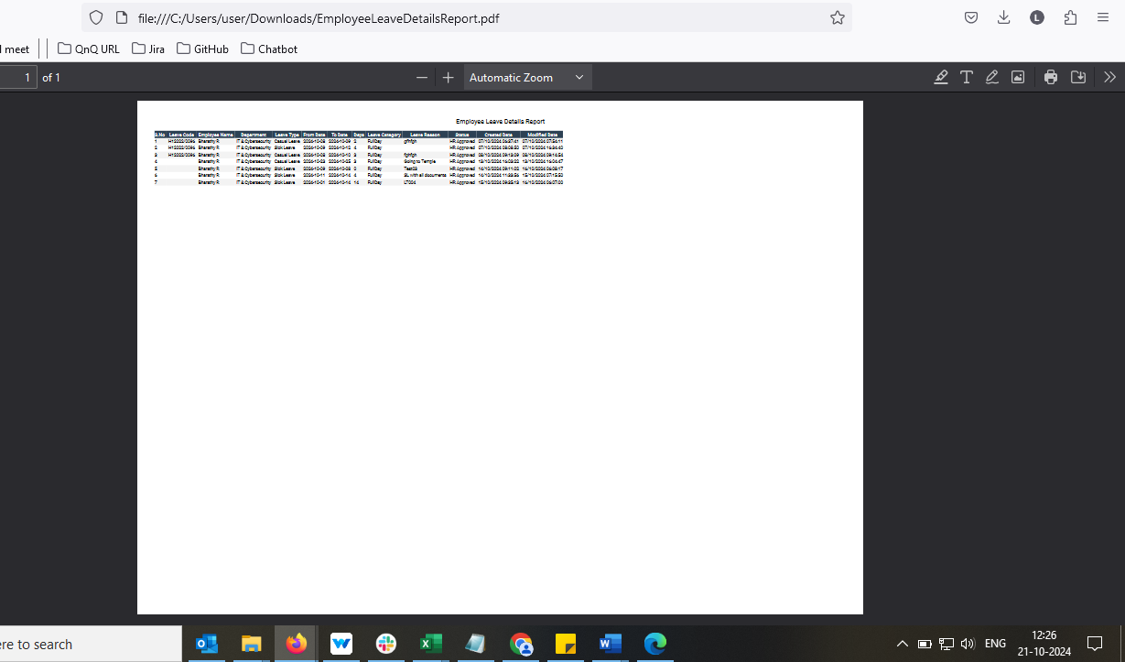 //
11. Header column not display while open the downloaded pdf 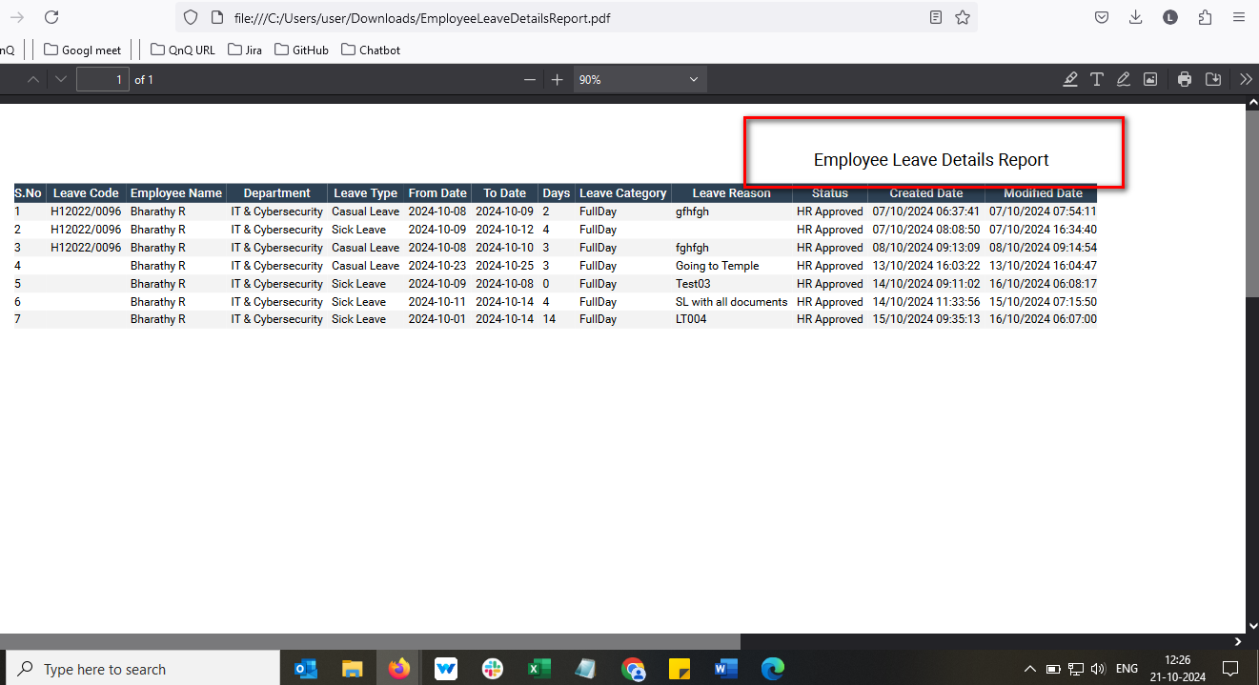 //
12. Sheet name not display in Csv file 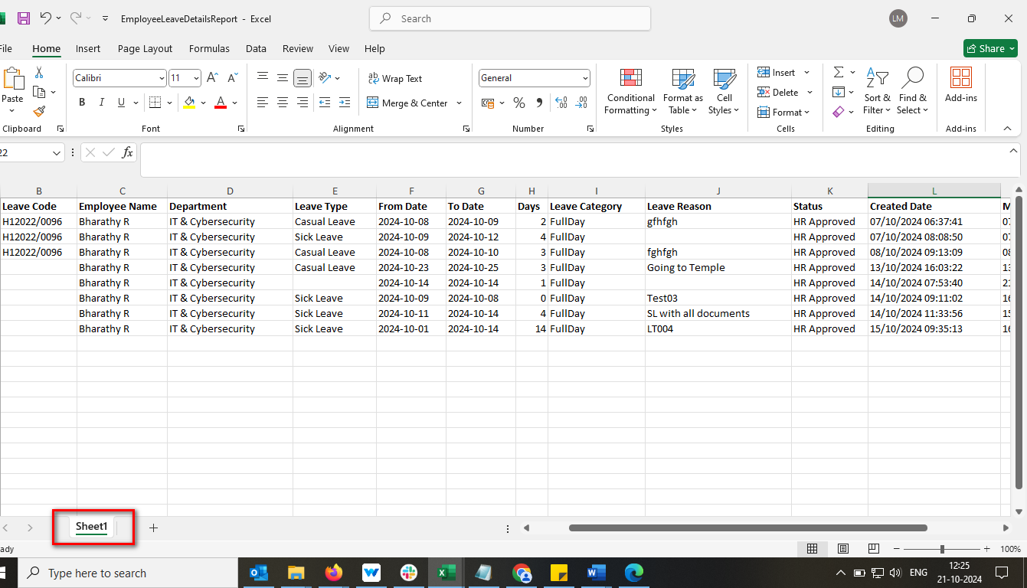 //
13. Mismatch File name display in the download file 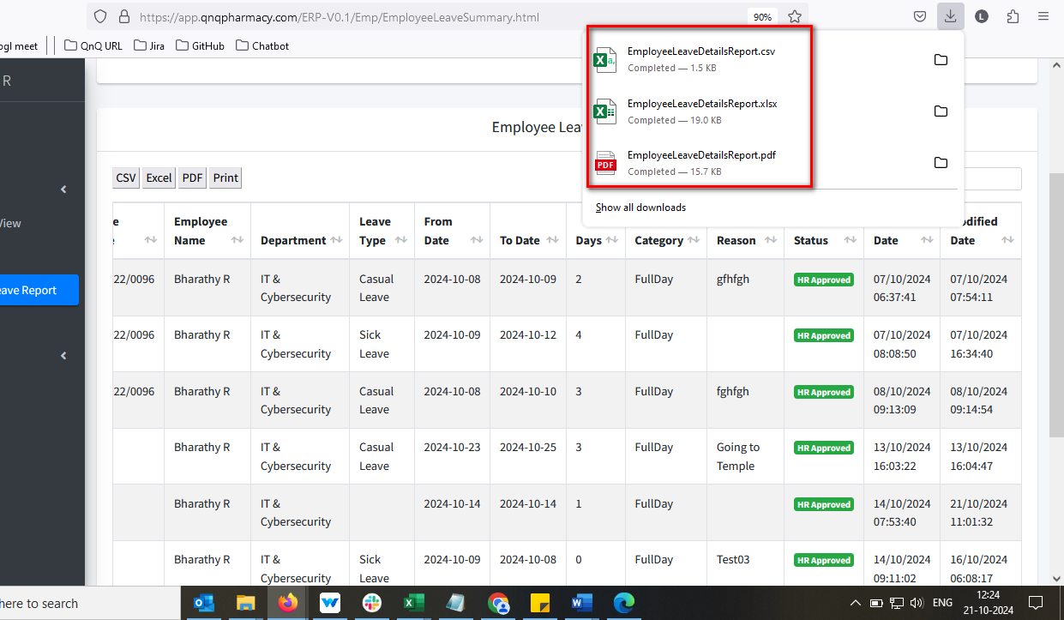 //
14. Hash value display while open the downloaded Excel 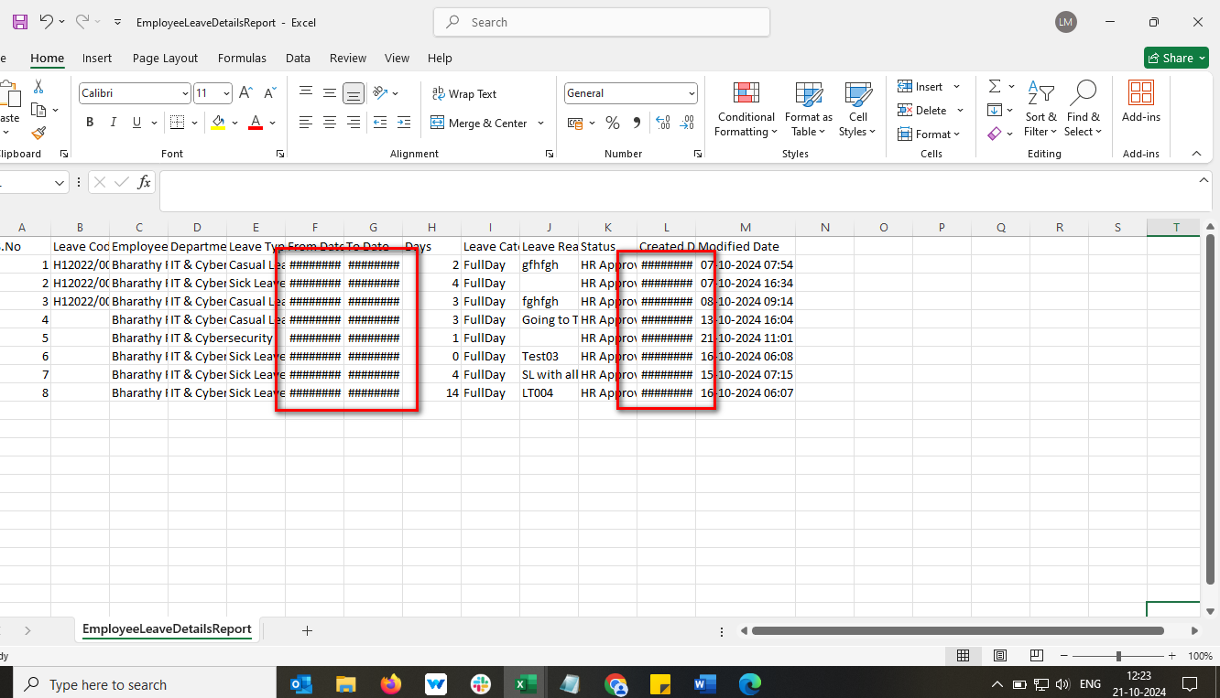 //
15. Values not display properly while open the downloaded Excel 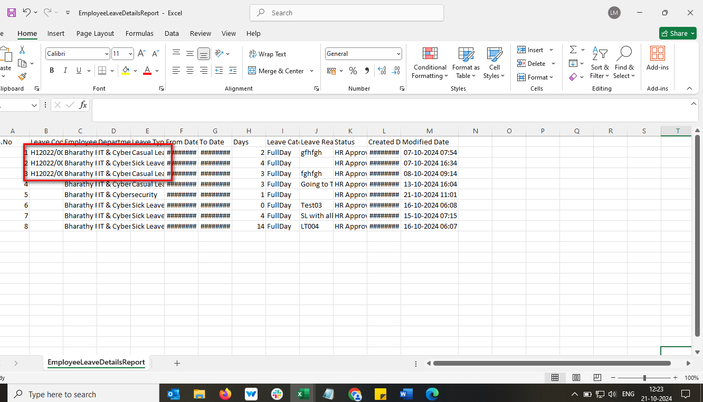 //
16. Header column value not display properly while open the downloaded Excel 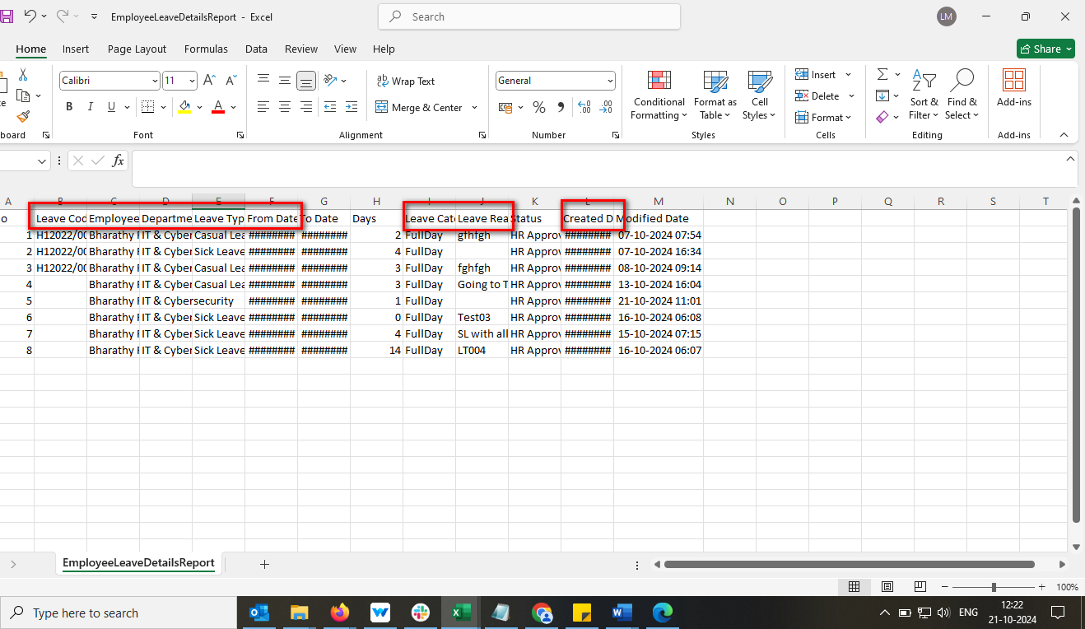 //
17. Sheet name display without space in Excel file 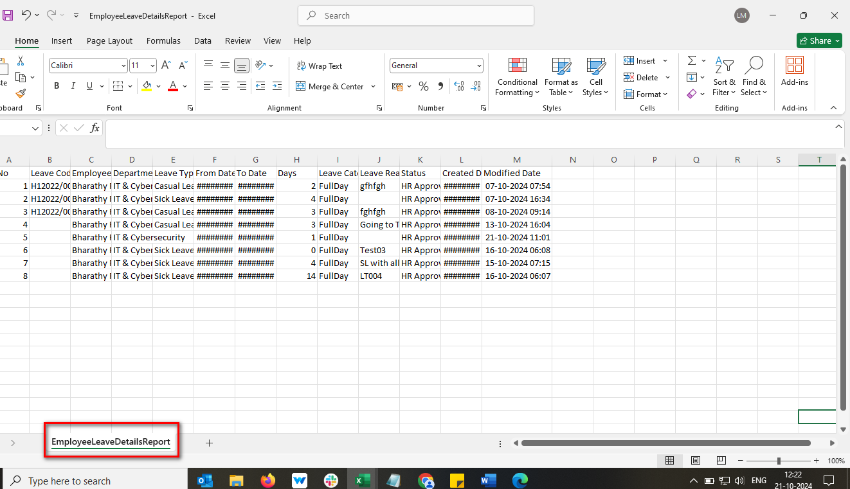 //
18. Space not display in Leave Category value 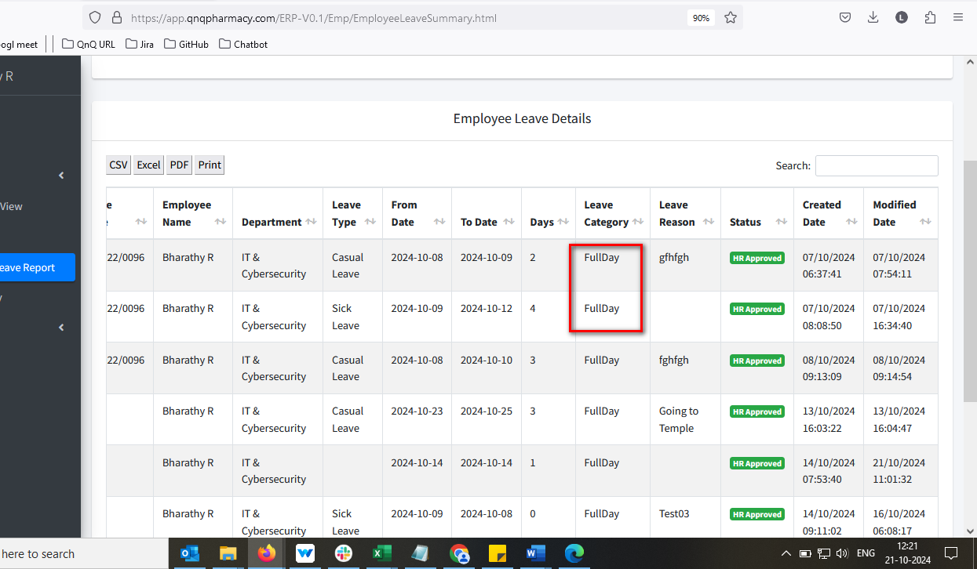 //
19. Given date value not getting clear while click refresh icon in webpage 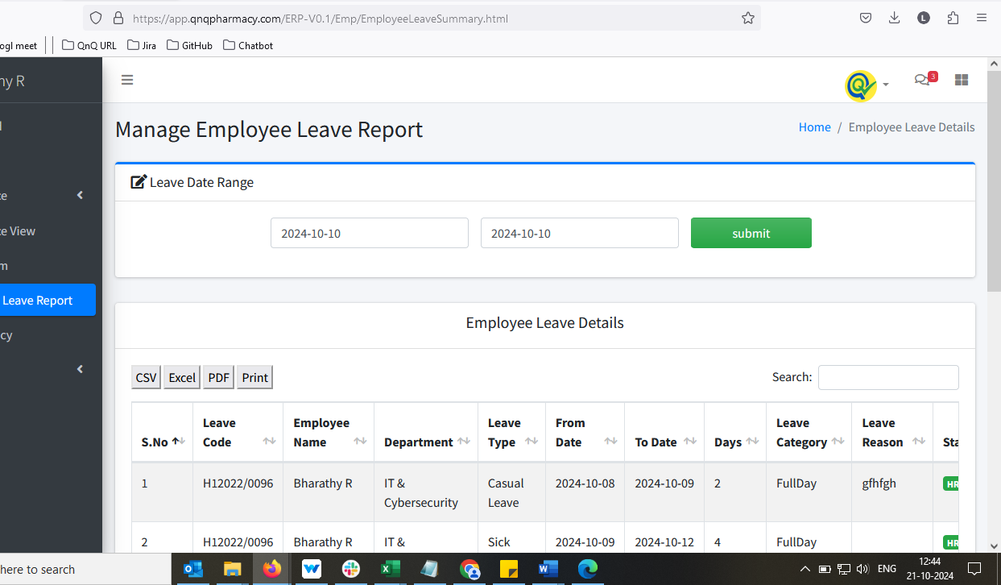 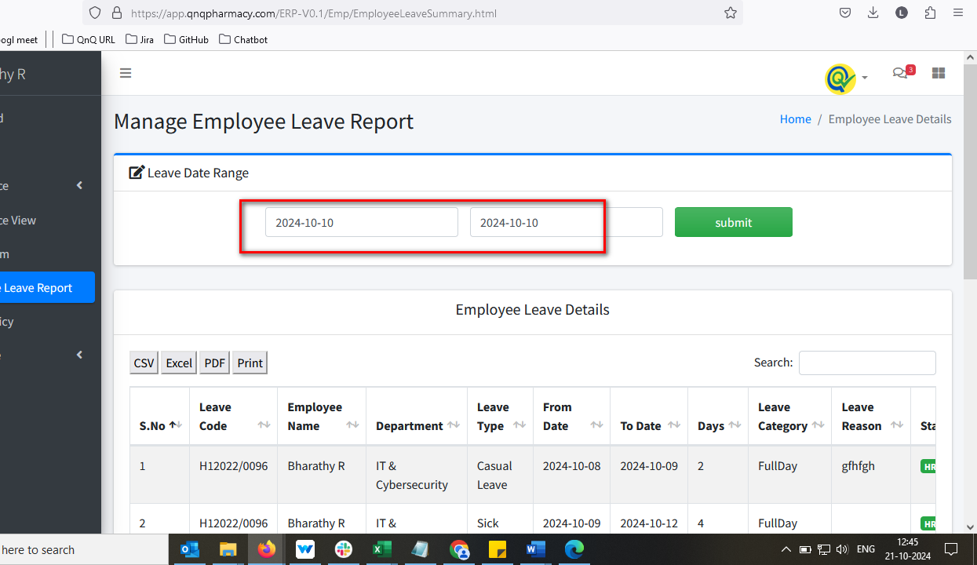 //
20. The date field permits letters and special symbols when pasting content 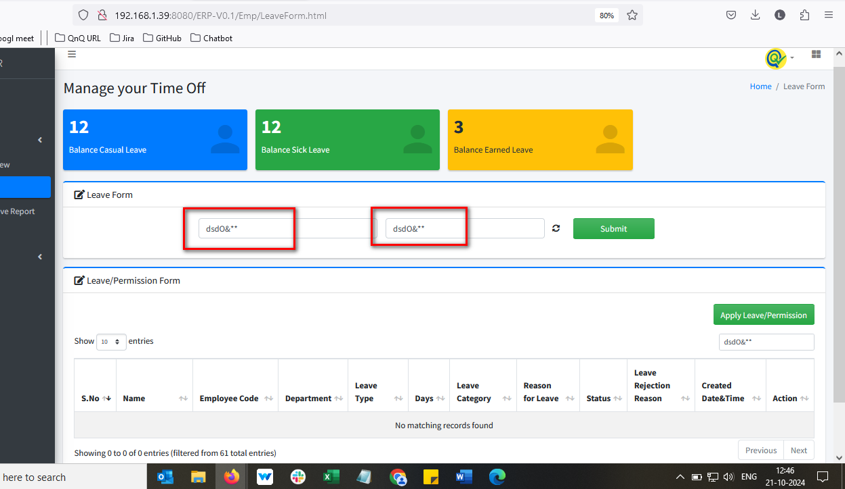 //
21. Summary list grid display for permission record 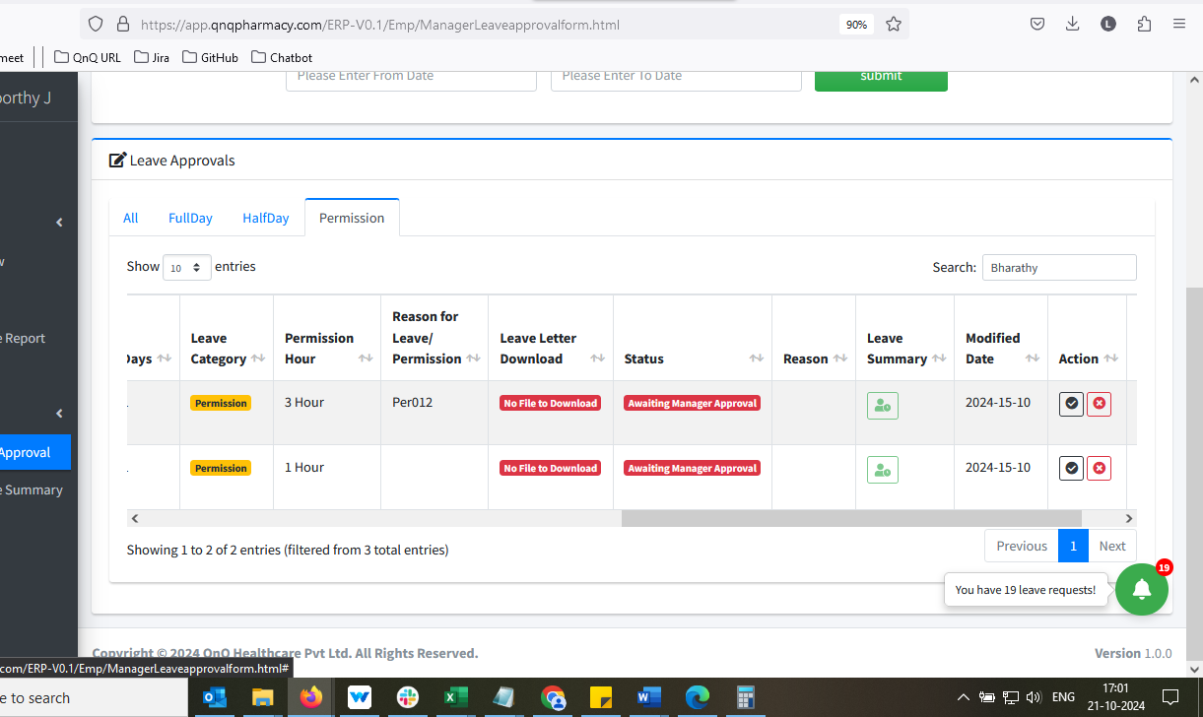 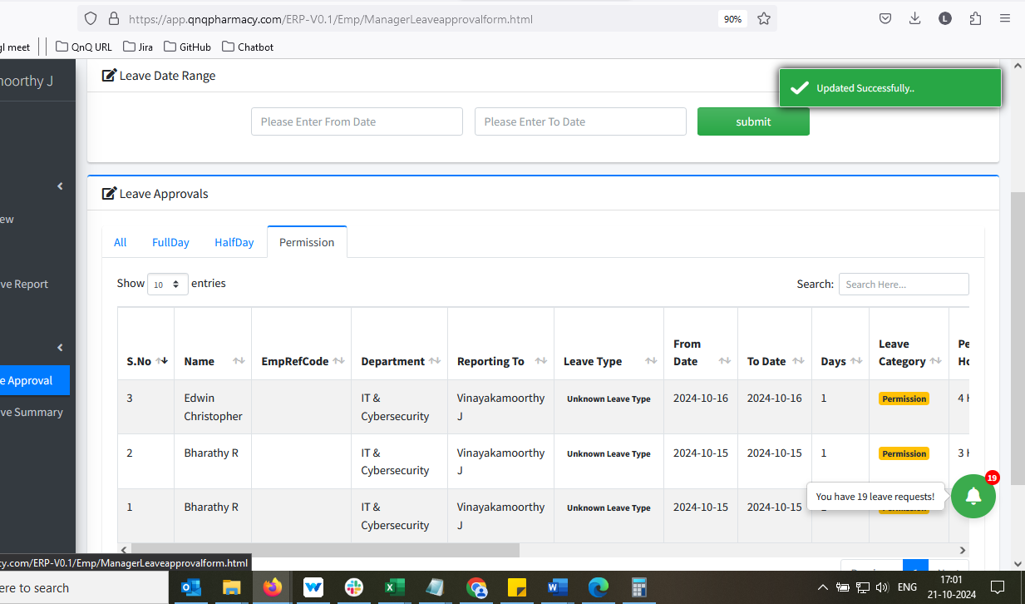 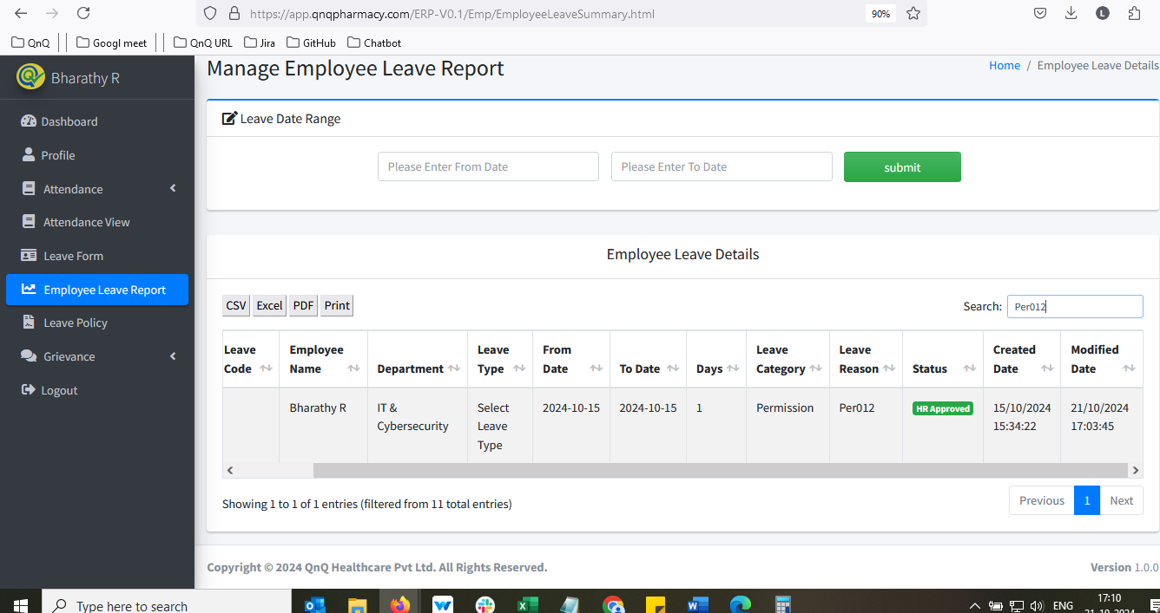//
22. //